NAME………………………………………………………..SIGN………………………….

P535/2

PHYSICS

PAPER 2

$$2\frac{1}{4} HOURS$$

UGANDA CERTIFICATE OF EDUCATION

MOCK EXAMINATIONS 2017

S.4 PHYSICS PAPER TWO

DURATION: **2hours 15 minutes.**

**INSTRUCTIONS:**

Answer **ONLY FIVE** questions. ALL questions carry equal marks.

*Any additional question(s) answered will* ***not*** *be marked.*

*Mathematical tables and silent non-programmable calculators may be used.*

*These values of physical quantities may be useful to you.*

* Acceleration due to gravity $g=10{ms}^{-1}$
* Speed of sound in air ${320ms}^{-1}$
* Density of water ${1000kgm}^{-3}$

1. (a) (i) What is meant by the terms scalar and vector quantities? Give two examples of each (4 marks)

(ii) State the conditions under which a body is said to be in mechanical equilibrium.(02)

(iii) Two forces of 80N and 60N act on a body of mass 10kg. Find the resultant force; hence find the acceleration of the body.(04 marks)

(b) Differentiate between potential energy and kinetic energy. (02 marks)

(c) A ball is thrown vertically upwards by a student. State the energy changes which take place starting from the instant just after throwing it up to when it has just been caught back by the student at the same point. (04 marks)

1. (a) What is a magnetic field? (01 mark)

(b) Draw a diagram of the magnetic field pattern between;

(i) The south poles of two bar magnets placed near each other along the same line (02)

(ii) Two straight conductors placed vertically near each other carrying current in the same direction. (02 marks)

(c) Describe briefly the:

(i) Electrical method of magnetizing a steel rod.(03 marks)

(ii) Mechanical method of demagnetizing a steel rod. (02 marks)

(d) A transformer is designed to produce an output of 240V when connected to a 25V supply. If the transformer is 80% efficient, calculate the input current when the output is connected to a 240V, 100W lamp. (05 marks)

1. (a) (i) What is meant by the terms mechanical advantage and efficiency as applied to simple machines. (02 marks)

(ii) Explain why the efficiency of any practical machine is always less than 100%.

(02 marks)

(b) The diagram below shows a load of 20N being raised by a frictionless pulley system.

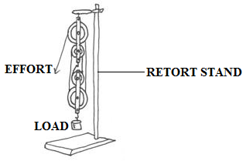***Figure 1***

(i) What is the velocity ratio of the system? (01 mark)

(ii) Calculate the effort required to raise the load if the mass of each pulley is 0.2kg.

(03 marks)

(iii) If the load is raised through 5m, calculate the efficiency of the system. (03 marks)

(c) Describe how the efficiency of a pulley system of a practical machine varies with the load (05 marks)

1. (a) With the aid of a labeled diagram, describe an experiment to show how the pressure of a fixed mass of a gas varies with temperature at constant volume (05 marks)

(b) A gas of volume 1000cm3 at a temperature of 170C is heated at constant pressure until its volume becomes 1250cm3. Find the highest temperature reached. (04 marks)

(c) Explain why a car radiator is painted black (02 marks)

(d) (i) Define the term latent heat of vaporization (01 mark)

(ii) A calorimeter of mass 20g and specific heat capacity $800{Jkg}^{-1}k^{-1}$ contains water at ${30}^{0}C$. Dry steam is passed through the water in the calorimeter until the temperature of water rises to ${70}^{0}C$. If the specific latent heat of vaporization of water is $2,260,000{Jkg}^{-1}$, calculate the mass of condensed steam. (04 marks)

1. (a) With the aid of a diagram explain the terms amplitude and wavelength as applied to wave motion. (03 marks)

(b)(i) Write down an equation relating velocity V frequency f and wavelength of a wave. (01 mark)

(ii) A radio wave is transmitted at a frequency of 150MHZ. Calculate its wavelength if the speed of electromagnetic waves in air is $3×{10}^{8 }ms^{-1}$. (03 marks)

(c) (i) Give four properties of electromagnetic waves. (04 marks)

(ii) Describe an experiment to show that sound waves require a material medium for their transmission. (05 marks)

1. (a) Explain each of the following observations;

(i) The pressure in a car tyre is greater at the end of a journey than at the beginning.(02)

(ii) The bodies of mountain climbers swell out when they reach high altitudes. (02 mks)

(b) With the aid of a well labeled diagram, describe how a force pump raises water from a well. (05 marks)

(c) In the figure below, piston P has surface area $0.4m^{2}$ while Q has a surface area of $2.4m^{2}$. If a downward force of 500N is exerted on P, find the maximum load which must be raised by Q.

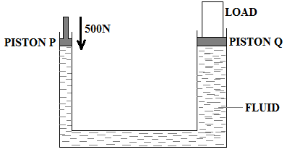***Figure 2***

1. (a) Define the following terms;

(i) Principal focus of a converging lens (01 mark)

(ii) Real image (01 mark)

(b)(i) With the aid of a labeled diagram, describe a simple experiment to determine the focal length of a converging lens.(06 marks)

(ii) State two applications of converging lenses. (02 marks)

(c) An object 8cm high is placed perpendicularly on the principal axis 30cm away from a converging lens. If the height of the image formed is 4cm, use graphical method to find the;

(i) Focal length of the lens

(ii) Distance of the image from the lens. (06 marks)

1. (a)(i) Name the radiations emitted by radioactive nuclides. (03 marks)

(ii) Give one property common to the radiations named in (i)(01 mark)

(b) A stream of particles from a radioactive source passes through an electrical field as shown below.

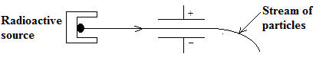

(i) Identify the particle in the stream(01 mark)

(ii) Give two properties of the particles identified in (b) (i) above(02 marks)

(c) (i) Define the terhalf life(01 mark)

(ii) X grams of a radioactive material of half life 3 weeks, decays and 5.12g remains after 15 weeks. Determine the value of X. (04 marks)

(d) (i) Distinguish between the terms fusion and fission. (02 marks)

(ii) State two conditions necessary for each to occur (02 marks)

**END**